**Guide for SBOM POC**

Step 1: The Home page of the SBOM POC is displayed as follows

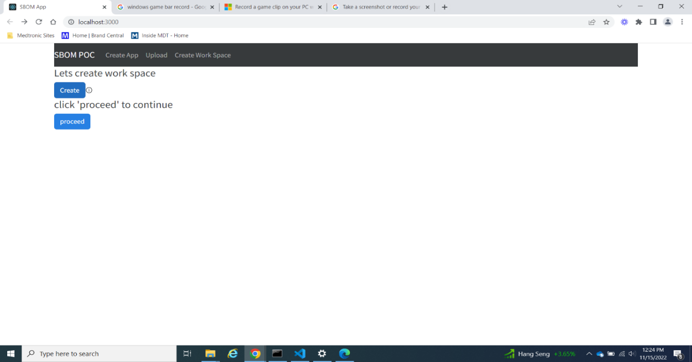

Step 2: Click Create workspace to store source code in server. Click Ok in alert to proceed.

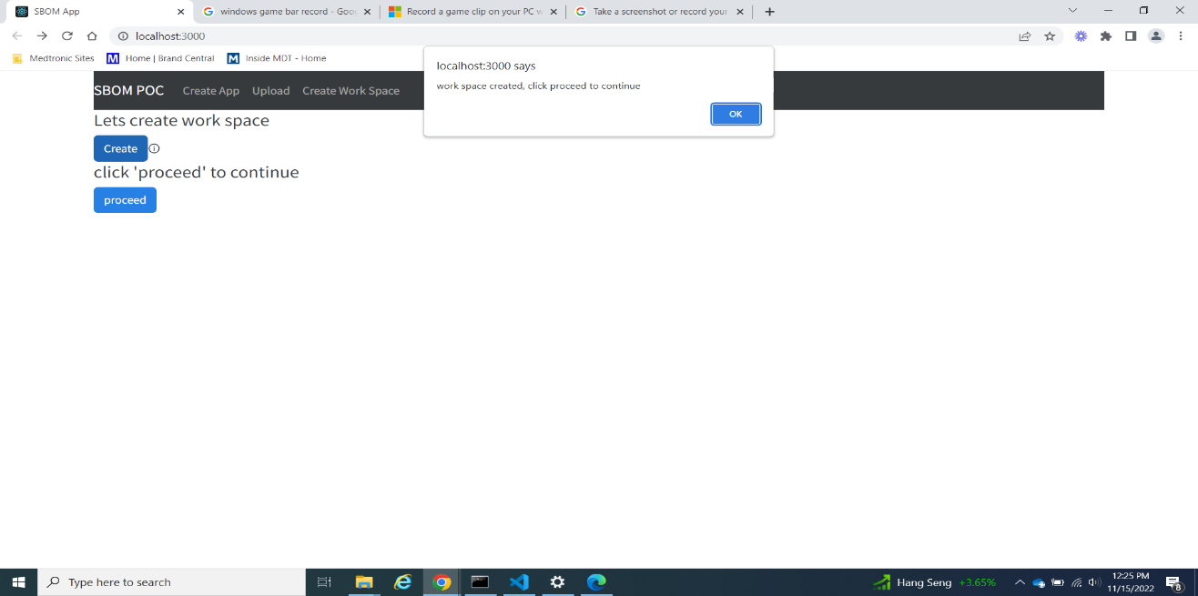

Step 3: On Click of proceed Upload page would appear.

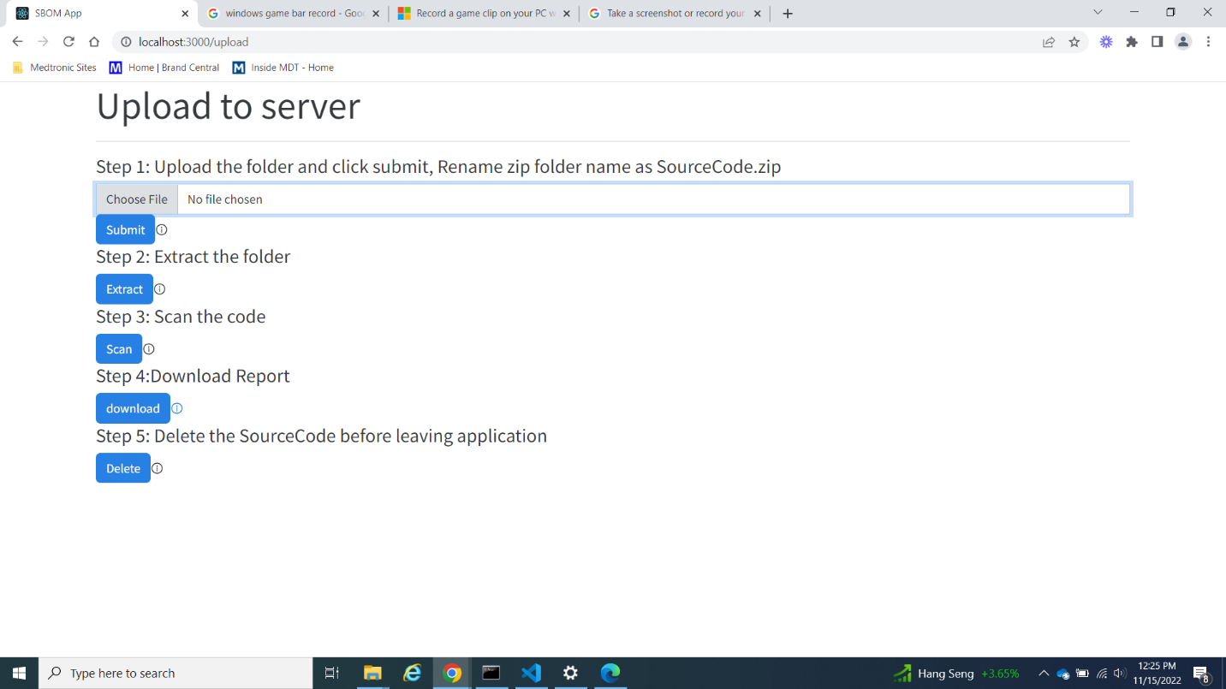

Step 4: Upload Source code folder as a Zip file. Make sure to rename the folder as SourceCode.zip

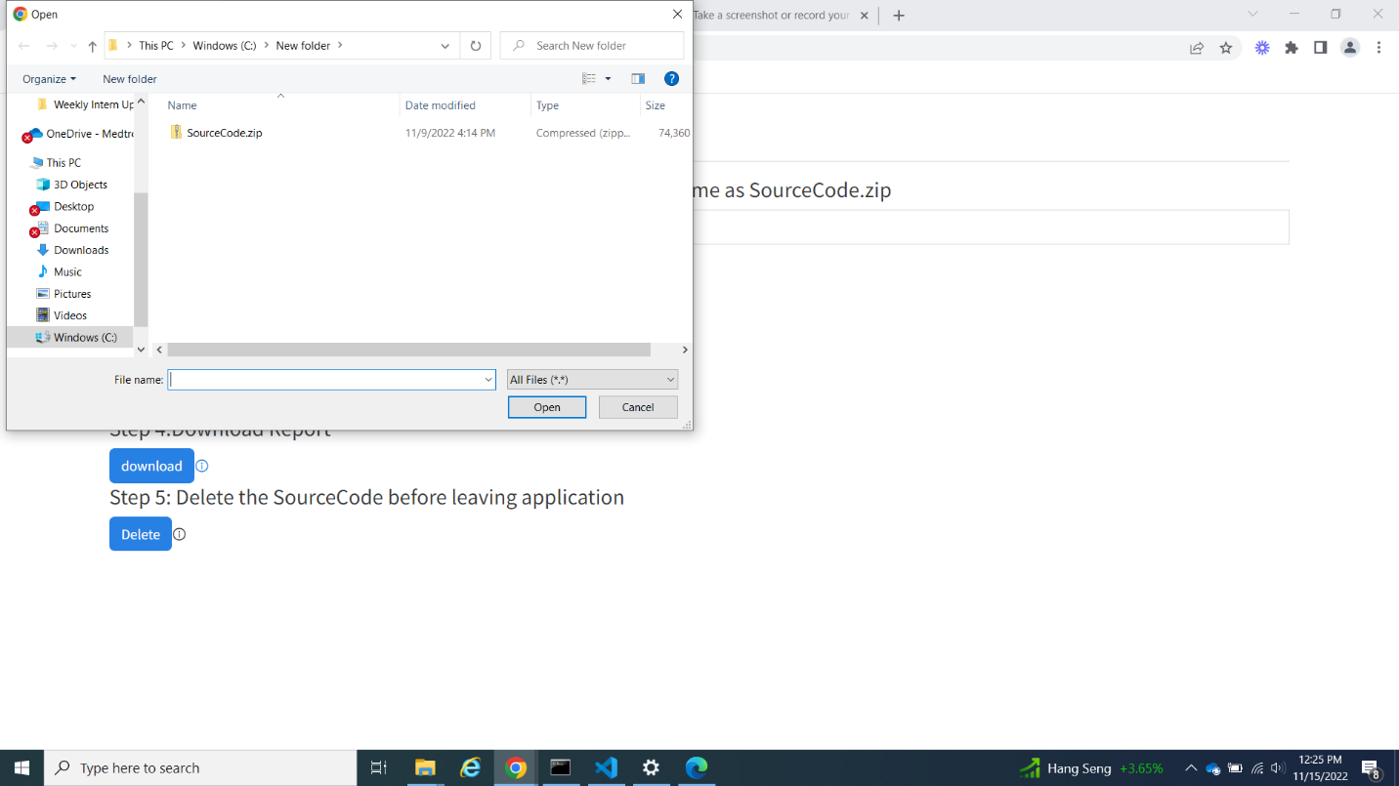

Step 5: Once Upload is Complete ‘OK upload is complete Extract the folder’ message is displayed onscreen.

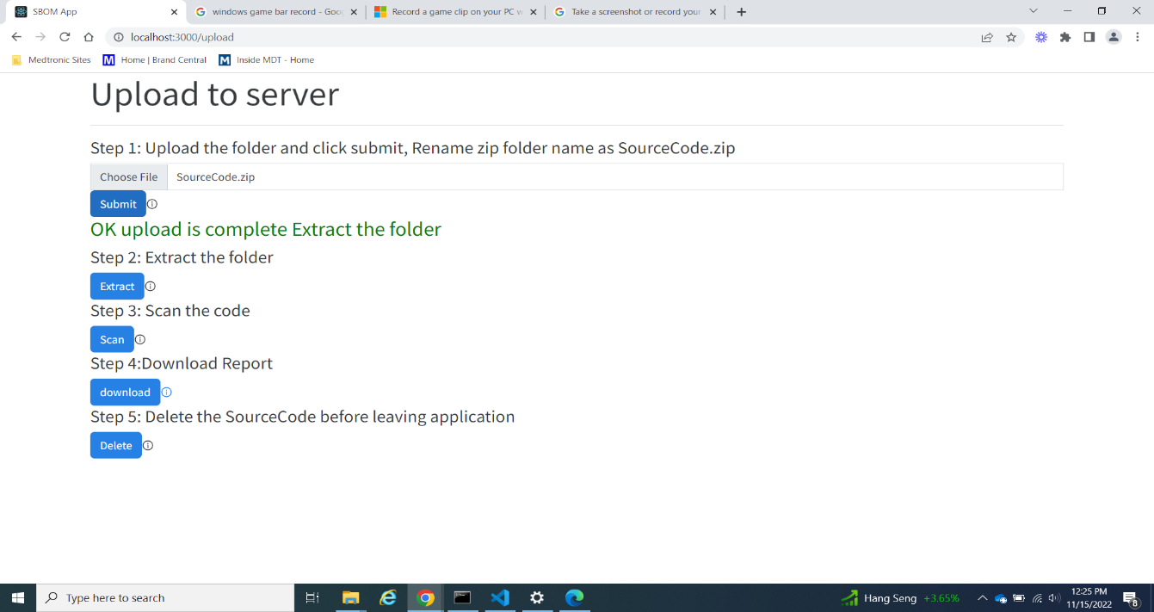

Step 6: On clicking Extract button alert is displayed on screen saying that Extraction is in progress.

Step 7: Once Extraction is Complete ‘ Ok Extraction Complete proceed to scan’ message is displayed on screen.

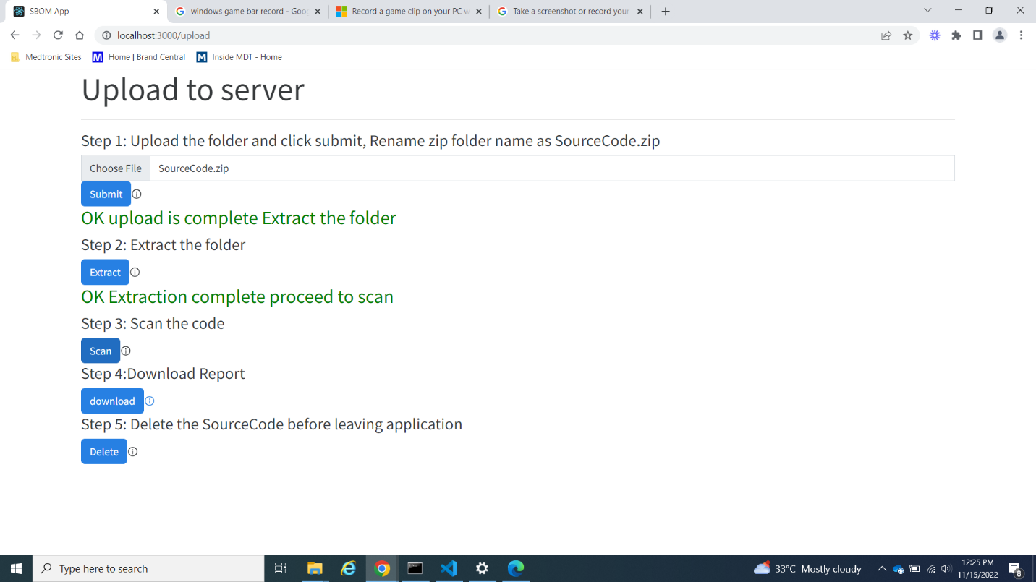

Step 8: On click of scan button alert is shown saying scan in progress.

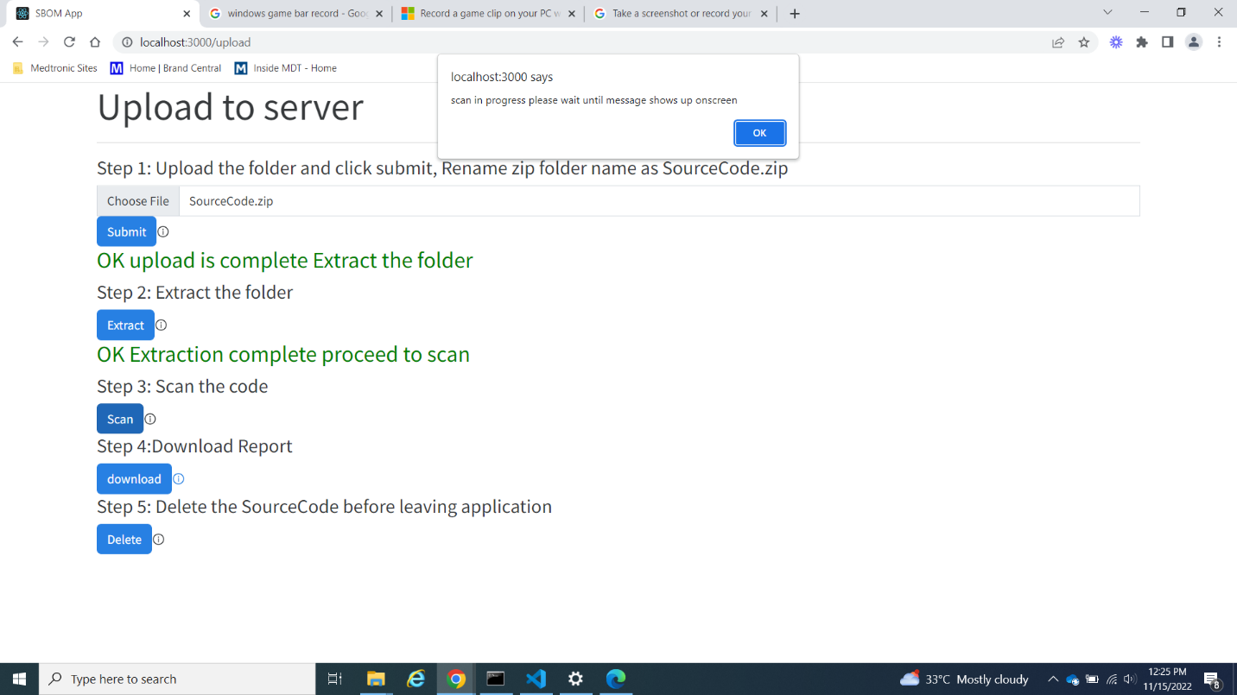

Step 9: When scan is completed ‘Ok Scan complete proceed to Download’ message is shown onscreen. You may proceed to download dependency check generated report.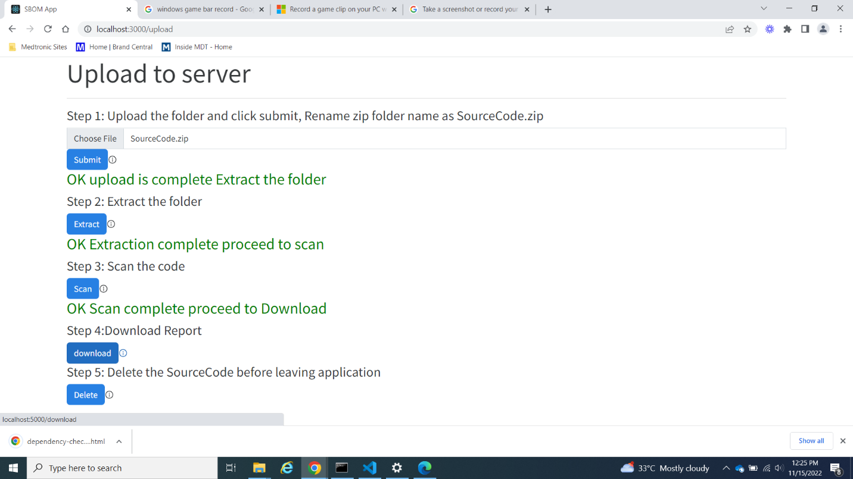

Step 10: On Downloading Report Click Delete. So that the backend clears the source code in server and makes it available for other users.

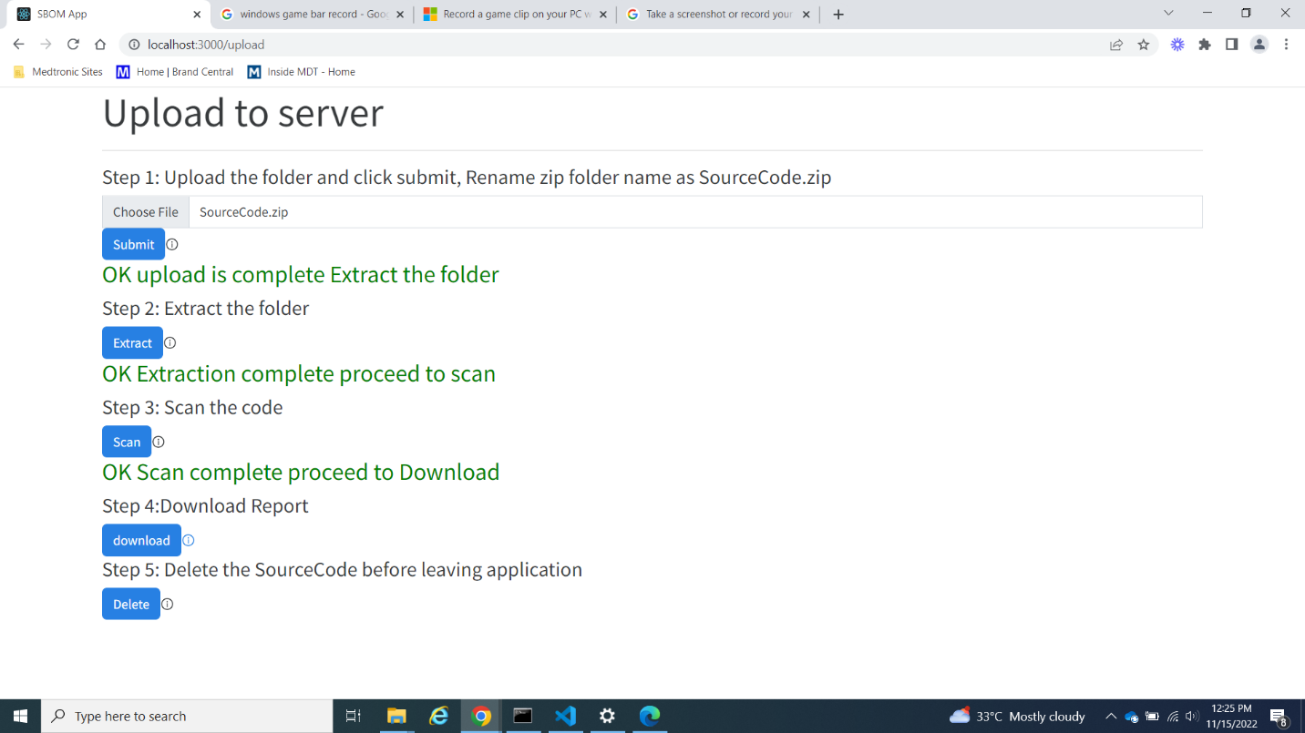

Step 11: Once deletion is complete ‘Ok deletion complete message’ is shown. Now you may leave the application or continue with new Source code.

